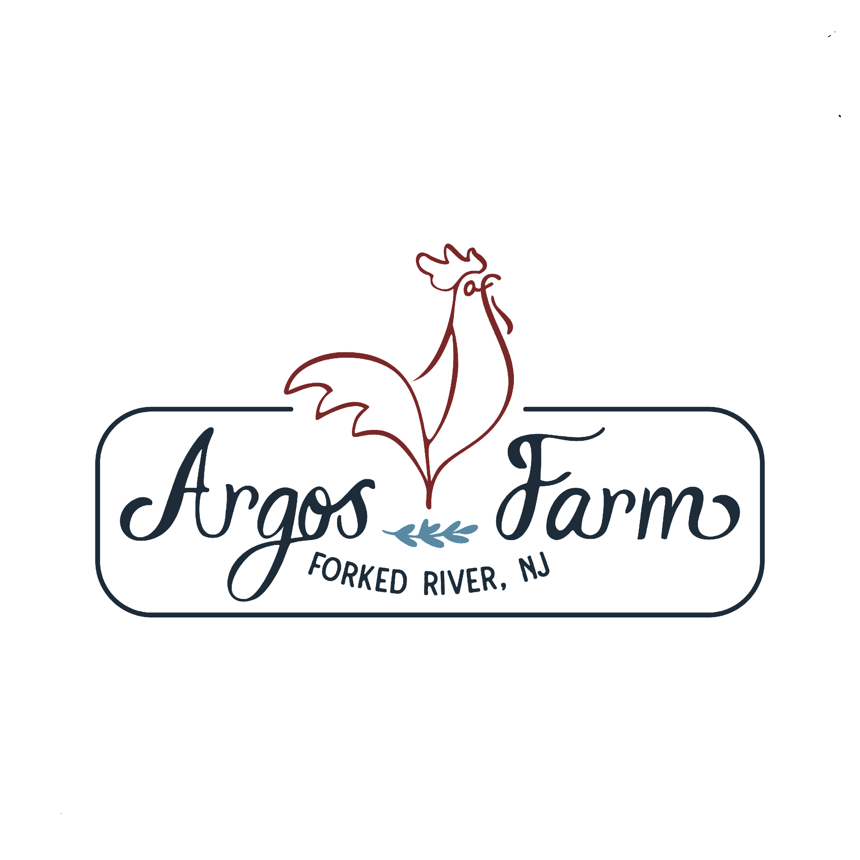

**FARM CAMP REGISTRATION FORM**

Argos Farm, 1250 Lacey Road, Forked River, NJ 08731

**Farm Camp is for 7 - 13yr. olds from 9:00 - 12:00pm**

WEEK OF __________________________

Name of Camper__________________________________________________________ Male ( ) Female ( )

Mailing Address____________________________________________________________________________

City_________________________________________________ State___________ Zip Code______________

Day Phone __________________________________ E-Mail________________________________________

Birth Date ______________________ Age ____________ Height___________ Weight _________________

**Emergency Contact**______________________________ **Phone** ____________________________________

Relationship to Camper _____________________________ Parents’ Names____________________________

Any physical and/or emotional limitations, or allergies? __________________________________________________________________________________________

__________________________________________________________________________________________

**\*PLEASE ATTACH A HEALTH CERTIFICATE SIGNED BY A DOCTOR.**

A note from your child's pediatrician stating that there are no physical limitations and up to date with their vaccinations is needed prior to the first day of camp. The pediatrician's signature on his/hers prescription pad is sufficient. NO need to bring in records of vaccinations or have another physical.

**WEEK of __________**

**______ $250.00 per week & 50.00 registration/insurance fee- Check#_________ Cash_________**

I understand that $50.00 of the cost of the camp is a non-refundable processing fee in the event of a cancellation. Argos Farm will not hold a space for any program after 5/1/22 without a 50% deposit. Full payment is required to hold a spot after 5/2/22. I understand that 50% of the camp fee, less the $40.00 processing fee, is refundable before May 1, 2022. I understand there are no refunds given if this registration is cancelled after May 2, 2022, or if my family or child(ren) do not show up on the first day of the program, or if my family or my child(ren) leave the program early for any reason. There are no cancellations! Please remit checks to: **SEAD Farming, LLC**

PARENT/GUARDIAN _____________________________________________________ DATE___________________________

**Please contact Angela @ 908. 890. 1633 prior to mailing registration to ensure availability.

[www.ARGOSFARM.com](http://www.argosfarm.com)

Campers should bring a bottled water, snack, light lunch, and

wear long pants, waterproof shoes, sunglasses, hat, sunscreen & bug spray.